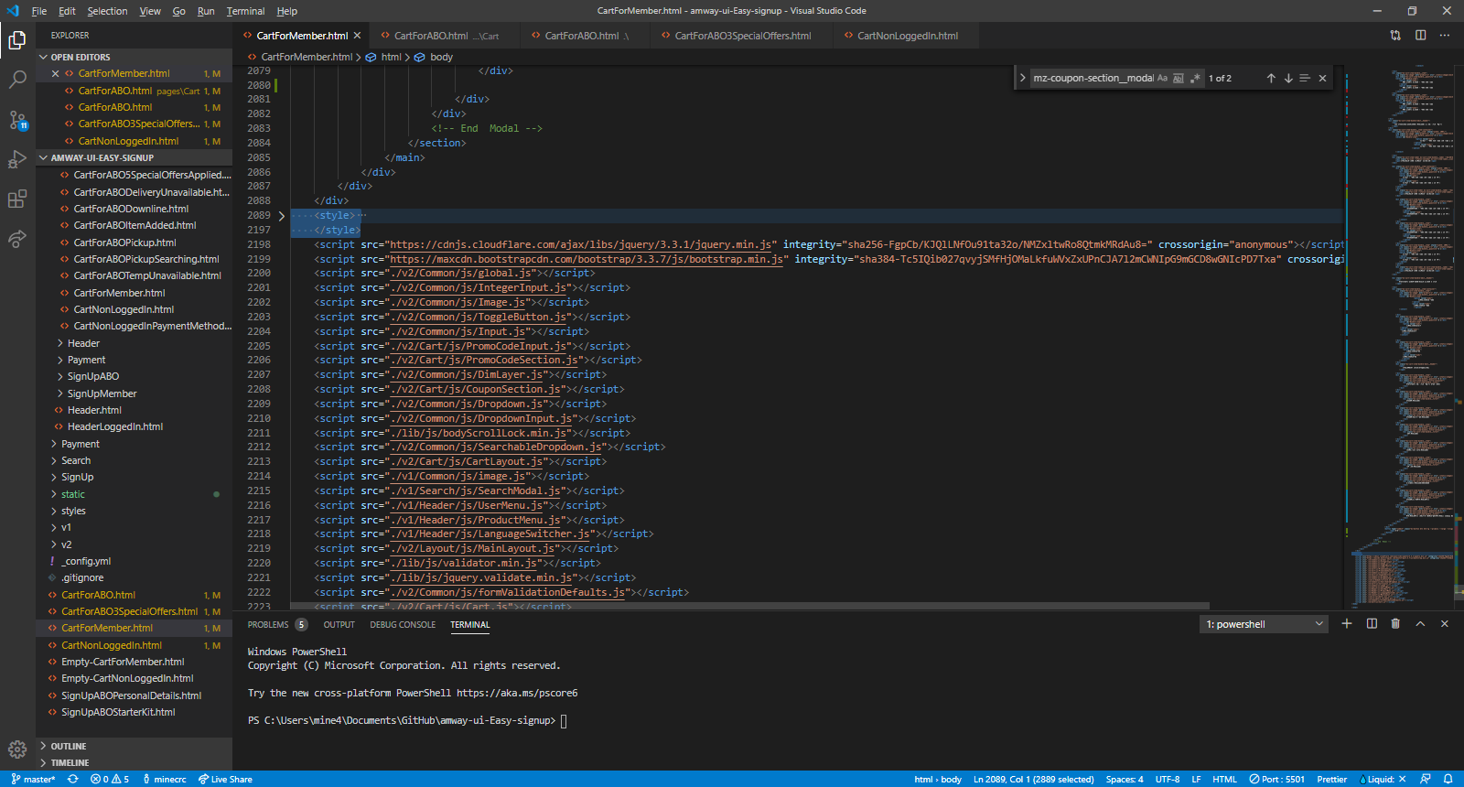

This picture is showing where you can find style that custom edit in to page.

It contains Class and style their necessary for Bundle Edit box.

Next. from comment Modal   
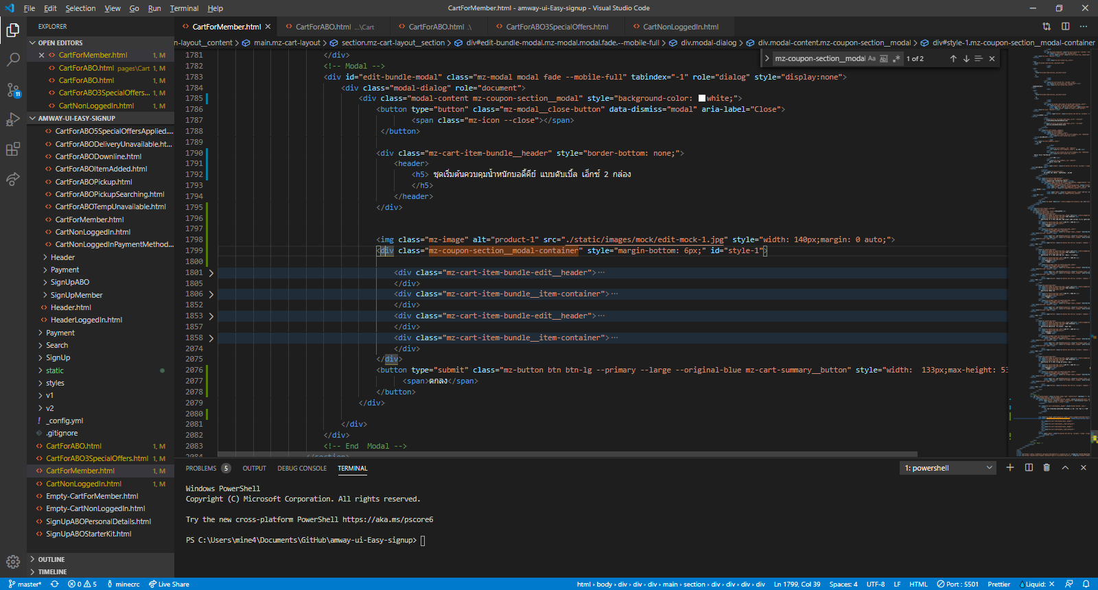  
Under these DIV  <div class="mz-coupon-section__modal-container" style="margin-bottom: 6px;" id="style-1">

this is the section that you can edit freely base by design.